Neon Goals.
To build a Java based in-house distributed low latency calculation framework with a similar architectural and interface style to form a replacement to the Sonaris SAF directed graph framework & our existing in-house SAF Controller, while avoiding the need to re-write the entire pricing library.

Constraints
The architecture is to a large extent driven by the limited resource available. At the start of this project it was agreed we would have 2.5 full time equivalent (3.75 man years) people working on Neon for 18 months. In reality, we have recorded 1.8 full time equivalent people the past 13 months (less than 2 man years so far). This contrasts very sharply with the original Sonaris implementation of 6 full time equivalent people over 2 years (12 man years). Even more so because the original implementation did not build the framework.

Origins
The Neon framework started its life as my personal project that I worked on for about 14 months prior to bringing it into Commerzbank. The original intention was to produce an open source directed graph framework.

Architecture Overview.

Neon is formed of two distinct components:
- The Neon framework. A neutral calculation framework that can be used to facilitate any directed graph.
- The Desk controllers. An interface component that takes interacts with the eBond system and builds a graph in the Neon framework.

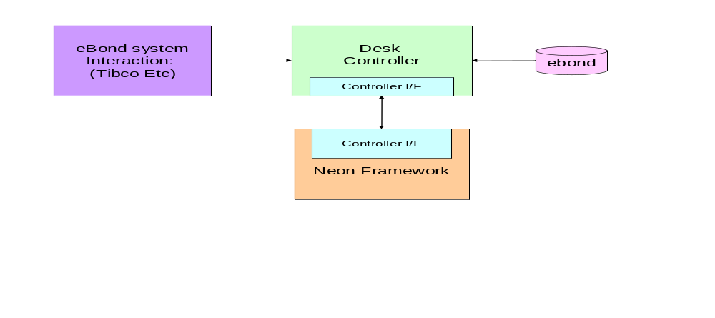

The Neon Framework

High Level Concepts
The Neon framework is not a pricing engine. It is an API that allows you to build a directed graph of nodes, where each node can have multiple inputs and a single output, and the output of any Node can be linked to the input of 0 or more Nodes. Conceptually, this is analogous to Excel:

Concept | Notes
Organisation using a tree of nodes | In the same way that adjacent cells are not necessarily computationally related in Excel, nodes next to each other on the tree in Neon are not necessarily related.
Cascading values through the graph. | Any node can link to any other node, anywhere on the graph through the use of the API. A Node has 0 or more inputs, and a single output
Node function | A set of custom nodes for basic operations are supplied managing simple math. Custom Java nodes can be deployed, and can use JNI to link to native libraries.
User scaling | Whereas Excel (generally) operates on a single machine with single user, Neon runs on a server and users connect a UI to the server to manipulate the graph through the API. All users can connect and manipulate the same graph concurrently.  (Although in our use of Neon, the direct manipulation of the graph through the UI is an occasional support function, with most manipulation being through the eBond client via the desk controller.)
Volume Scaling | Neon has the ability to scale by spawning as many processes (JVM) as is needed. This is through the API rather than in response to load. Special mounting points on the tree can be assigned to any process. Where a value on one JVM process is needed on another JVM process
Automation | There is a Java API binding that can connect to the framework to manipulate all aspects of the tree. The UI connects using the same API.
Speed | The routing cost is negligible, leading to a very low-latency system. Inside a JVM process, the routing cost is of the order on 10's of nanoseconds. From JVM to JVM the routing cost is of the order of a few micro seconds. (This can be improved a lot by replacing TCP communications with a shared memory solution)

Architecture

The core of a Neon deployment is the Controller. The controller manages all access to the Neon system via API. The API is just a jar that can be included in any Java server or client side application.
The API provides a simple interface for manipulating the graph.

The actual calculations occur inside bags
Through the API, A routing hub and
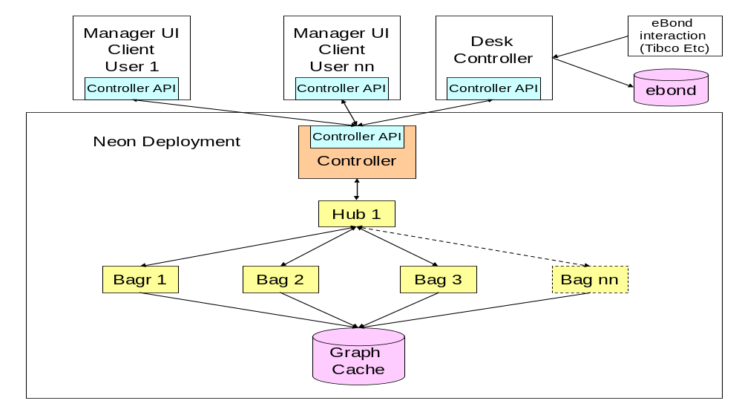

The Desk Controllers

Deployment
- The system needs its own database, preferably located very close, if not on one of the machines in the ‘cluster’
- Orange items are deployed & run on standard Linux servers using our standard deployment mechanisms.
  - Each machine has to have the spawner running as a daemon service.
  - One machine deploys the controller will be the machine that the remote client’s connect to to use the API’s
- Yellow topology nodes are distinct JVM instances that are created on demand by the controller via the spawner.
- Topology structure is maintained by using the blue controller interface.
- The UI Manager client uses the controller interface to interact with the system visually.
  - i.e. maintaining topology, maintaining calculations packages, stats, logging, introspection Etc.
- A Server Based client will use the controller interface to bridge business changes into the system.

Technical Stack
- Java 1.7_04
- Spring 3.1.1 - Core / AOP / ORM / JDBC / Security
- Hessian 4.07
- Disruptor 2.7
- Swing
- Log4j
- Data: Postgres / Hibernate / Spring. (Can simply switch to use any RDBMS dialect)
- Testing: jUnit, jMock, Grinder

